SAMPURNA ATMARAMANI
E-Mail: s.atmaramani@gmail.com/ Phone: 09323895896 / 09860817217

Profile Summary & Experience Highlights
Hands on Fullstack React Frontend + Node Backend Developer | Python FastAPI (AI Enhancements) | Software Implementation & Support | Playwright UI automation specialist | Devops | Unit testing specialist | DevSecOps Specialist | Observability specialist | Project Management | CDK Programming -Typescript – Infra as a Code | AWS Certified Solutions Architect Professional | Micro Frontend Architecture (WebPack | Vite) | Micro Services Architecture (Kubernetes + Node JS + Rabbit MQ) | Nest JS for Backend Development

20 years of hands on development experience in full life-cycle development projects; ramping up projects within time, budget & quality parameters across e-Commerce, Internet Advertising, Inventory Mgt, Gaming, International Language Education & Learning domains
Industry Preference: IT Location Preference: Pune

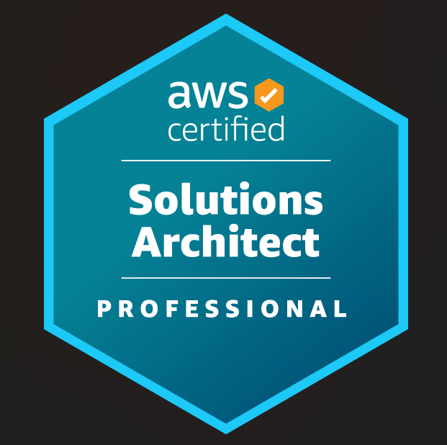AWS Certified Solutions Architect Professional

https://www.credly.com/badges/eba93c7b-b0c5-4891-8ece-38f45bda1cef/public_url

Click here to visit my online portfolio link



Sr. No. | Title | Link / Details
1 | Linkedin Profile | https://www.linkedin.com/in/sampurna/
2 | Medium.com Tech blogs (more than 190 Tech blogs on various topics) | https://medium.com/@s.atmaramani
3 | Seasoned YouTuber | https://www.youtube.com/@techysam-bl9mk/videos
4 | Github.com React JS Kickstart Boilerplate Link | https://github.com/satmaramani/react-js-tutorial-sample-code-by-sam-atmaramani
5 | ChatGPT API’s Integration with React JS Code – Translation / Images API’s / Generations / Sentiment Classifiers / ChatBOT /Spell Corrections / Sentence Completions etc | https://github.com/satmaramani/chatGpt-api-with-react
6 | Udemy Videos  - React JS Hindi (Free)  - ChatGPT Complete Master class (Paid)  - Webpack & Micro Front end Architecture  - React JS 100 Key Concepts  - Playwright automation using javascript | https://www.udemy.com/user/sampurna-atmaramani/
7 | Conducted Internal Corporate level Trainings in Infogain on following topics  - Webpoack  - React JS  - ChatGPT Masterclass | Imparted trainings on ChatGPT & Webpack Masterclass in Infogain  Private youTube Video Links here  - https://youtu.be/-MUUq_SHw54 – ChatGPT part 1  - https://youtu.be/hgYyaUMVu6c - ChatGPT part 2  https://youtu.be/E1BXSU7Exds - Webpack
8 | Conducted Internal Corporate level trainings in Synechron on Playwright Automation tool using Javascript Tech Stack | - Video not making available because of legal reasons
9 | 3 own Npm Packages Developed for Javascript Community | - https://www.npmjs.com/settings/s.atmaramani/packages



Sr. No. | Title | Details | Period
1 | Received Star Performance Award for outstanding performance | [Synechron] | April 2024
2 | Employee of the month | [Synechron] | April 2024
3 | Top Performer Employee | [Infogain] Received high performing Employee Bonus in 6 Digit amount (Reflected in Salary Slip) | April 2023
4 | Employee of the Month | [Infogain] Received Infogain Employee of the Month Award | Jan 2023
5 | Infogain Hero Award | [Infogain] Received Infogain Hero Award – for all rounder activities | Sep 2022
6 | Top Trainer in Cybage | [Cybage] Included in top trainers List in Cybage | Year 2012
7 | Topped MS Final Semester | Distant Learning – Software Engineering(Bits Pilani) | Year 2012
8 | Cybage Certified Trainer | Cybage Certified Trainer from Cybage | Year 2012
9 | Got Recognized in Infogain Got Talent (Oct 2022) for playing one song (Hai apna dil to Awara) in 4 ways  - Flute  - Keyboard  - Mouth Organ  - Singing | [Infogain] https://www.youtube.com/watch?v=EtBuTKD1q8A | Year 2022
10 | Udemy instructor  - ReactJS  - Playwright Automation  - ChatGPT masterclass  - Webpack | Average Rating 4.6 | Between 2022 to 2025

Key Skills  ~Javacript Fullstack Hands on Developer  ~AWS Certified Professional  ~Playwright automation specialist  ~Devops activist  ~Unit testing specialist  ~DevSecOps Specialist  ~ Application Development & Maintenance  ~ Project Execution  ~ Requirement Gathering  ~ Technical Solution  ~ Change Request Management  ~ Client Relationship Management  ~ Liaison & Coordination  ~ Team Management  ~Observability tools |  | Hands on Fullstack Coder / Developer (react, node and AWS ) & Hands on UI Automation Specialist using Playwright Javascript + Seasoned Software Technical Architect + DevOps with extensive software designing experience in end-to-end scalable (Kubernetes) and AWS serverless (Lambda ) software architecture design, hands on development, and deployment, spanning enterprise applications, microservices-based systems, Micro Front end Implementation using WebPack, cloud-native solutions. Proficient in driving technology strategies, designing scalable systems, and ensuring alignment with business goals.  • Proven expertise in solution architecture and software development lifecycle (SDLC) management, including requirements analysis, technical design documentation, and implementation oversight, ensuring robust and maintainable systems. Skilled in mentoring teams to deliver quality solutions in complex, fast-paced environments.  • Adept at translating business requirements into architectural blueprints, defining functional and technical specifications, and identifying business impacts and benefits. Experienced in creating high-performance, resilient systems by adhering to modern design principles and industry best practices.  • Strong experience in performance optimization, capacity planning, and designing for high availability and fault tolerance. Hands-on expertise in tackling non-functional requirements such as scalability, security, and data durability to ensure systems meet critical business needs.  • Demonstrated ability to lead and grow cross-functional teams. Played a pivotal role in expanding offshore teams from a single engineer to over 100+ engineers, ensuring seamless coordination with stakeholders across geographies. Proven ability to influence technical roadmaps while balancing stakeholder priorities.  • Expertise in architecting and developing dynamic web and mobile applications using modern JavaScript full-stack technologies and hybrid frameworks. Delivered projects end-to-end, from inception to deployment, including publishing apps on Android Play Store and iOS App Store.  • Accomplished in managing maintenance and operational support of enterprise systems, resolving incidents efficiently, and ensuring SLAs are met. Hands-on experience in production support, problem resolution, and preventative maintenance strategies.  • Extensive experience working with international clients and senior leadership teams. Successfully gathered requirements and kickstarted a new project in the United States, enabling offshore team expansion and fostering a productive onshore-offshore collaboration.  • Proficient in cloud platforms (AWS, Azure) and modern DevOps practices, integrating CI/CD pipelines, security frameworks, and observability tooling. Skilled at designing and implementing solutions to ensure business continuity and operational excellence.  • Visionary leader, capable of driving strategic technical initiatives while mentoring and inspiring teams to deliver innovative solutions. Strong ability to evaluate new technologies, propose proof of concepts, and optimize existing systems for better performance and cost efficiency.  • Salesforce / Zoho CRM Integration  "Integrated Salesforce and Zoho CRM with internal applications using REST APIs to automate lead sync, customer data flow, and sales analytics."  • CMS Experience (WordPress & Drupal)  "Developed and customized CMS-driven websites using WordPress and Drupal, including plugin/module integration, theme customization, and content workflow optimization."  • ERP – Odoo Modules  "Implemented and extended Odoo ERP modules for billing and inventory management, streamlining operations and improving reporting capabilities."  • Collaboration Tools (Jira + Confluence + Monday.com + Asana.com + Trello + Mantis)  "Facilitated agile workflows using Jira for sprint planning and issue tracking; created and maintained project documentation in Confluence to support cross-functional teams."  • CRM Data Dashboarding  "Designed and deployed web dashboards by fetching CRM data (Salesforce/Zoho) via APIs, enabling real-time sales and customer insights for stakeholders."  • Used Vercel and Railway for backend and front end dev deployment and automatic pipelines

Technical Stacks / Tags

AWS , Azure, Github actions, JENKINS , Alibaba Cloud, Node JS, React JS, Angular JS , Webpack, Micro Front end, JEST Unit testing, Mocha, Vue JS, PHP, Code Igniter, Zend Framework, Laravel, Angular JS, HTML5, AJAX, Jquery, Bootstrap, Mysql RDBMS, MongoDb NoSQL, Sql-Lite , GIT, SVN, JIRA , Automation using playwright , docker , Kubernetes , CDK Programming using Typescript, Promethus, Grafana, NestJS

AWS Cloud Flavours Used
AWS S3 / RDS Database (MySQL) / API Gateway/ Cloud Front / Cloud Watch / Firewall / Route 53 / AWS Code Commit / Code PIPELINE / AWS Build / Cognito / AWS Lambda / Amazon ECS / Amazon VPC / Amazon DynamoDB / Amplify / AWS CDK / Lambda / API Gateway / IAM

Azure Cloud Flavours used
Azure Devops , Ingress, PODS, Containerization , AZURE Storage , Azure functions , Virtual Machines , AKS Clusters , API Management , AZURE CDN , FIREWALL, cost managmenent, backup , Azure site receovery , Azure Cosmos DB

Organisational Experience
Project Since August 2023 to Current Sr Architect & Hands on dev at Synechron Technologies Pvt Ltd (Employee since Aug 2023)

Company Name : -Synechron Technologies
Client Name :- asurion Insurance services (US)

Technology Stack
Node.js, TypeScript, JavaScript, AWS, DevOps, Playwright Automation, GitHub Actions, React.js, CDK Programming for Iaac (Infrastructure as a code)

Role
As a Technical Architect & Hands on fullstack Dev, responsible for code writing, designing, implementing, and overseeing solutions that align with organizational goals. Lead and mentor a diverse team of 20 members, providing technical direction and strategic guidance. Maintain hands-on involvement in critical aspects of coding, unit testing, and automation testing using Playwright to ensure the delivery of high-quality, scalable solutions.

Key Result Areas
- CDK Programming for consistent Infrastructure setup using version control (using typescript programming language)
- Requirement Analysis & Solution Design: Collaborate with clients and onshore teams to gather business requirements, translate them into technical architectures, and define scalable, high-performance solutions.
- Sprint Planning & Capacity Management: Prioritize requirements, create sprint plans, and allocate team capacity effectively to ensure timely and efficient delivery of commitments.
- Technical Leadership: Provide expert technical guidance to a cross-functional team of 20, including frontend and backend developers, UI designers, QA engineers, and DevOps specialists. Mentor team members to build their expertise in modern technologies and frameworks.
- Execution & Delivery Oversight: Drive project execution by monitoring progress, managing risks, and delivering solutions that meet functional and non-functional requirements such as scalability, security, and performance.
- Code Review & Quality Assurance: Ensure the quality of deliverables through meticulous code reviews, adherence to coding standards, and implementation of robust testing practices. Advocate for continuous improvement in code quality and performance.
- Hands-On Contribution: Actively participate in coding, particularly in complex and critical areas, and automate testing workflows using Playwright. Leverage deep expertise in JavaScript and related technologies to solve technical challenges effectively.
- DevOps Integration: Oversee CI/CD pipeline configurations and ensure smooth deployment processes, using GitHub Actions and modern DevOps practices.
- Cross-Team Collaboration: Act as the primary bridge between technical teams, design teams, and stakeholders, facilitating seamless communication and alignment of project goals.

Project Since April 2023 to August 2023 Technology Lead at Infogain India Pvt. Ltd. (Employee Since Jan 2021)

Company Name :- Infogain India Pvt Ltd.

Project Name: SavATree.com

Role: Architecting and Managing the Delivery of Micro Frontend Systems

Technology Stack
React.js, Webpack , JEST, React Testing Library, AWS, Micro Frontend Framework, Micro UI, Java Backend

Role Overview
As a technical leader aspiring to the Architect role, my primary focus was on designing, managing, and ensuring the successful delivery of React.js Micro Frontend Systems. I was responsible for guiding a team of multiple developers in implementing scalable, modular, and reusable frontend components. Collaborated with the client and stakeholders to align technical solutions with business objectives while fostering a culture of technical excellence and innovation.

Key Responsibilities
- Solution Architecture & Design: Spearheaded the design of Micro Frontend and Micro UI architecture to ensure modular, scalable, and high-performance systems that aligned with client requirements and industry best practices.

- Client Requirement Analysis: Acted as a key liaison between the client, onsite teams, and the offshore development team, translating business requirements into technical specifications and actionable plans.
- Sprint Planning & Execution: Worked collaboratively to define sprint objectives, manage team capacity, and ensure timely delivery of commitments, aligned with predefined timelines.
- Team Mentorship & Technical Oversight: Provided technical mentorship to a cross-functional team, including frontend and backend developers, UI designers, QA engineers, and DevOps specialists. Guided them in adopting best practices in React.js, JEST, and AWS-based development workflows.
- Code Quality Assurance: Ensured high-quality deliverables by conducting detailed code reviews, enforcing coding standards, and implementing best practices in testing using React Testing Library and JEST.
- Hands-On Technical Contribution: Played an active role in hands-on development, addressing complex implementation challenges, and building reusable micro frontend components.
- DevOps & Deployment Integration: Worked closely with DevOps engineers to integrate AWS CodeCommit, ensuring smooth deployment processes and optimized CI/CD pipelines for faster releases.
- Capacity Planning & Resource Management: Conducted capacity planning and resource allocation to balance workloads and ensure effective team utilization across all sprints.
- Retrospective Planning & Process Improvement: Facilitated sprint retrospectives, identifying improvement areas, and implementing feedback-driven changes for more efficient project execution.

Outcomes & Impact
- Designed and delivered a modular Micro Frontend architecture, enhancing scalability and reducing development time for new features.
- Improved code quality and reliability by establishing a rigorous code review process and introducing best practices in testing and automation.
- Fostered a culture of collaboration and technical innovation within the team, resulting in improved productivity and higher client satisfaction.

Since Jan 2021 to March 2023 Technology Lead at Infogain India Pvt. Ltd.

Company Name: Infogain India Pvt Ltd.

Client Name :- Seagate (US) Project Name: Azure DevOps Microservices Platform

Role: Technical Lead with Architect Responsibilities

Technology Stack
VueJS, Node.js (Backend), Azure DevOps, Jenkins, GIT, MongoDB, MOCHA/Chai (Unit Testing), Microservices Architecture

Role Overview
Led a cross-functional team of developers and QA engineers to deliver scalable microservices-based solutions using modern web technologies. Ensured alignment with client requirements while driving technical excellence, process improvements, and timely project deliveries.

Key Responsibilities
- Solution Design & Delivery: Architected and implemented microservices solutions with AngularJS and Node.js, integrating with MongoDB.
- Sprint & Capacity Management: Collaborated with the client to define sprint goals, manage team capacity, and ensure timely, quality deliverables.
- Technical Leadership: Provided hands-on technical support, conducted code reviews, and resolved critical technical challenges.
- CI/CD Management: Streamlined Jenkins pipelines and Azure DevOps workflows for automated builds and deployments.
- Quality Assurance: Established unit testing practices using MOCHA/Chai to enhance code reliability and maintainability.
- Team Mentorship: Guided team members in implementing best practices for microservices architecture and development.

Impact
- Delivered high-performance, scalable microservices solutions, meeting client expectations within defined timelines.
- Improved code quality and deployment efficiency through robust CI/CD pipelines and rigorous code review processes.
- Fostered a collaborative and high-performing team environment, enabling consistent delivery of sprint objectives.

Jul’14 – to Jan 2021 (7 Years) Honey Computing Services (HCS), Pune as Technical Project Manager

Highlights:
- Requirement gathering Design and Architect the software, planning and mentoring the team members, execute the projects, deployment strategies
- Interaction with client to gather their requirement through emails & voice calls
- Forwarded & explained the requirements to Development & QA Teams and ensured they understood the same
- Addressed technical fixing / understanding issues to solve, give the solution, motivate and get it fixed by team
- Worked on the tentative estimate and communicated to client for the same

Key Result Areas: -
- Design and develop the website and mobile app (Android Installable App) from scratch
- Architecting complex Multi-tenant subscription softwares
- Getting work done from team
- Handling Dedicated and cloud servers from Alibaba Cloud Services
- Used Cloud RDS Services as a database layer
- Used Cloud OSS (Object Storage Service) for Storing Images as a Secured Image server on Cloud

Technology Stack :- Node Js (Back End) , React JS (front end ), Cordova Platform , IOS , Android

Jul’06 – Jul’14 (8 Years) Cybage Software Pvt. Ltd., Pune as System Analyst & Project Lead (Joined as Software Engineer and elevated up to System Analyst Level 3)

Highlights:
- Selected as Top Trainer in FY 2013 - 14 by Cybage Training Department
- PHP Lamp Stack Developer
- Worked as a member of LAMP stack training division for 6 years and trained many freshers and Laterals during that period
- Imparted trainings on various topics like HTML 4, HTML 5, JavaScript, Object oriented JavaScript, jQuery, Angular JS, CSS, Bootstrap, IONIC, PHP, Code Igniter, Zend Framework, Object Oriented Programming (PHP), PhoneGap / Cordova & IONIC framework

Jul’05 – Jul’16 (1 Years) People Interactive Pvt. Ltd., mumbai ( shaadi.com ) as Junior Developer

Highlights:
- member of LAMP stack training division for 1 year1
- Tech Stack: PHP / Mysql / Apache / Jquery
- Frameworks : Zend Framework, Laravel, Code ignitor

Academic Details

- MS (Software Engineering) from BITS Pilani, Rajasthan (Correspondence Course from Cybage Software Pvt. Ltd.) in 2011
- Bachelor of Information Technology from KITS, Ramtek in 2003
- Diploma in Computer Technology from Govt. Poly, Bramhapuri in 2000

Certification / Training

- Cybage Certified Trainer from Cybage

IT Skills

- Programming: PHP, MySQL, JavaScript, JQUERY, AJAX, Angular JS 1, React JS , Code Igniter and Zend Framework
- Database: MySQL and SQLite (mobile devices internal database)

Personal Details

Date of Birth: 4th July 1980
Permanent Address: Flat No. 1, Wing B1, Vastushilp Apartment, Dhayari, Pune – 411041
Languages Known: English, Marathi and Hindi

~ Please refer the attached Annexure for Project Details ~

I confirm that above details are true and accurate to the best of my knowledge
Annexure
Projects Undertaken

Title: Coloring & Sketching online (using Javascript tech stack and cloud for deployment)
Description: Users can sketch free hand drawings, color filling using picking the colors etc , photo uploads, video recording, photo capture, audio video recordings, moving, stretching the texts in any direction on the canvas, showing / hiding UI layers with the help of opacity, download the final creation and share with friends

Python AI Enhancements Removing Image background and applying another background (Python removeBg), Compression of an image, Sentiment analyser and response in Audio and text format for Confession Room

Technologies Stack: React JS (Frontend), S3 (static assets i.e images and videos), Nest JS (Backend), Ec2 instance , Vercel (Front end deploy), Railway (For backend node js deploy) on Dev Environment, Python + FastAPI (for backend HuggingFace, pipelines, transformers, RemoveBg, sentiment analysis)

Title: CDK Programming using Typescript / Javascript
Description: Helped AWS Devops team to build, setup and launch version controlled AWS Infrastructure (IaaC – Infrastructure as a code) CDK Programming using Typescript and AWS SDK especially for serverless stack so that no need to manually undergo repeated manual process of manual infra setup

Stakeholders DevOps Team, Dev team, QA Team, Management

Technologies: Typescript, AWS SDK, Javascript, CDK (Cloud Development Kit)

Title: Implemented Sharding for Cucumber JS Frameowke (Complex)
Description: Created own workflow and implemented end to end Sharding feature for Cucumber JS projects which are being used by various teams in Asurion company for streamlining there huge UI test cases automations and dynamically run on various runners, run dynamic TAG related commands to distribute test cases on various runners separately, generate reports on the fly, combine all the reports into one common final report and deploy the reports on AWS S3 bucket for display purpose

Technologies: Typescript, Github Actions, AWS S3, NPM Packaging

Title: Inventory Management system
Description: Developed a very huge system to manage end to end inventory of a system including replenishment and refunds

Stakeholders Stockists, Dealers, Distributors, Administrator, End customer

Technologies: Node JS (Micro Services Backend) , ReactJS (Micro Frontend) , Database MySQL 8 on Cloud RDS, Image Server OSS on Alibaba Cloud (Buckets in different region Cloud CDN) for storing audio, video and images , Api gateway, Cognito Authorizer, Cloud Front , Load balancers, JWT Token system using authentication

Title: Create Dynamic Website In 2 minutes (android mobile app + website)
Description: This is a android mobile very quick website ceation tool which facilitates user to create his own subdomain website within 2 minutes, user can upload images, provide address for google map display, upload youTube Video link or any social media links, provide contact email Id and mobile numbers, mentions business details

His website users can contact the user by providing a contact form

Technologies: Node JS (Backend) , ReactJS (Frontend) , Database MySQL 8 on Cloud RDS, Image Server OSS on Alibaba Cloud (Buckets in different region Cloud CDN) for storing audio, video and images

Title: Advocate Diary and Case Management (myBestLawyer.in)
Description: This is a multi tenant very complex and huge advocate case management web application and mobile app for Android & IOS platform. Advocate can manage the cases using this software. Created this android and IOS app for offline mode (without internet using mobile device SQLite Database). It has admin section from wherein super admin can manage the subscription from back end, front end user can purchase the subscription for number of years. Daily push notifications and SMS Text messages are sent from server to app owner advocate and his / her clients for next day schedule. There are some background processes which runs on daily, weekly and monthly pre-scheduled time to do some specific job, for ex. sending whole month schedule t advocate and clients, send mail to expired subscription users for payment reminders and give discounts.
Technologies: PHP (CodeIgniter), MySQL, Angular JS 1 and IONIC Framework 1

Title: Liquor Inventory Management System using Bar Code
Description: This software is an inventory software using Bar code / QR code, this is a multi-tenant application to manage the stock of any products. this software has two interfaces 1) Admin to manage the users 2) User interface to manage the stock and inventory. Stock entry can be done using mobile device camera, which is intended to capture the bar code , map the product with the bar code and record the sale and purchase accordingly stock sales and purchase can be managed by import and export feature of any business also. One user can have one or more businesses and each business stock / inventory can be managed by the software.
Development Platform: Website and Android App
Technologies: PHP (CodeIgniter), MySQL, Angular JS 6 and IONIC Framework 4

Title: My Clinic and Patients Management (user facing and admin side)
Description: This software is a multi-tenant application created for managing the clinics, doctors or administrators can create the account and manage the patient’s information, their appointment, amount, reporting, next appointment and follow up.
Development Platform: Website and Mobile App
Technologies: PHP (CodeIgniter), MySQL, Angular JS 1 and IONIC Framework 1

Title: MPMC Pune - Maharashtra Police Megacity Android App
Description: This is a simple website & mobile app to manage home buyer’s information, user could see the status of their home development status. Admin could update the slab, status of home, payments, upcoming payment overdue, uploading latest home images, and so on.
Technologies: Angular JS 1 and IONIC Framework 1

Extra Curricular Activities Evidences

Training feedback for my ChatGPT training Rating 4.89 / 5
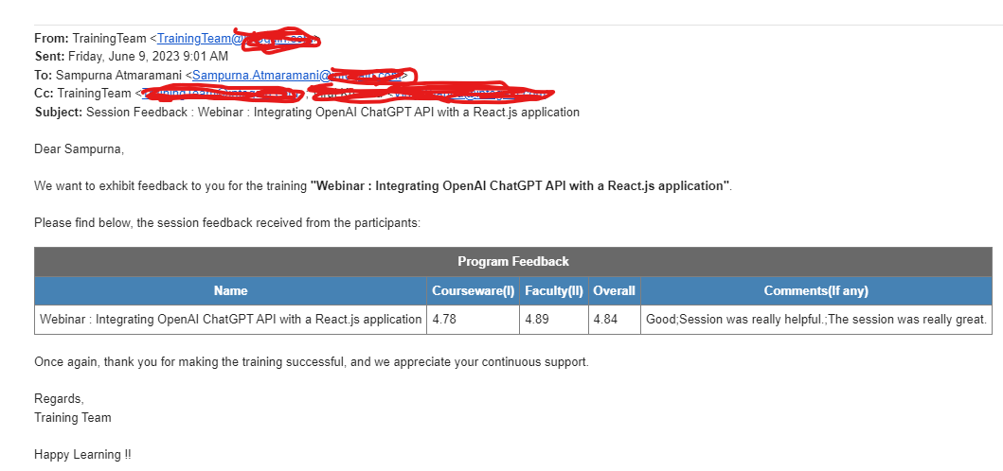

Training Feedback for my Webpack Training Rating 4.71 / 5

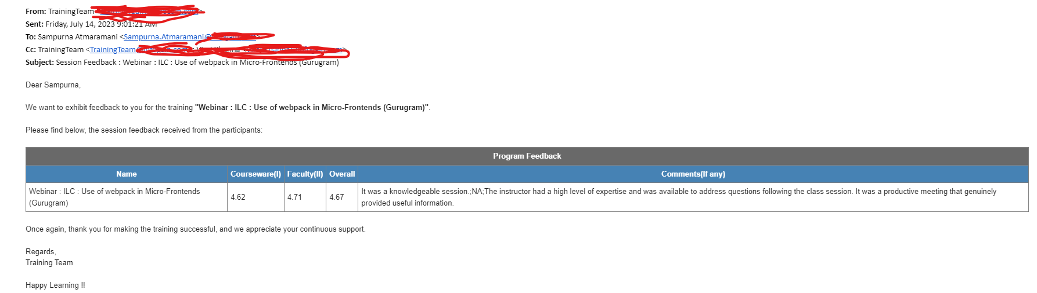

Achieved following features in many projects
(Functional and non functional requirements)

- Scalability
- Reliability
- Security
- Performance
- Usability
- Functionality
- Maintainability
- Compliance

Sincerely
Sampurna Atmaramani

I hereby confirm that the above information is true and I own complete responsibility of it

Sincerely

Sampurna Atmaramani
9323 895 896
s.atmaramani@gmail.com

